Setting up Outlook Add-in
- Setup is done by adding the URL, the WorkInSync app is not on the App Marketplace
- Installing from the Get Addins window in Outlook:
  - In the Outlook menu ribbon, click the ‘Get Add-ins’ button
  - In the Add-ins window that opens, select My add-ins, and scroll down until you see the Custom Addins section.
  - Click + Add a custom add-in and in the dropdown that appears select the ‘Add from URL’ option.
  - In the modal that opens, enter the URL of the manifest file (ex format - https://outlook.signature365.com/manifest.xml)
{Please reach out to WIS team for the right URL}
  - Review the warning and Select Install
  - The Signature 365 addin will appear in the Custom Addins section, and will now be available when composing a new message
- Deploying the add-in from the Microsoft 365 Admin center
  - Log on to the Microsoft 365 Admin center as a Global Administrator.
  - Go to Settings > Integrated apps to open the Integrated apps page, and click Upload Custom Apps to open ‘Deploy New App’ modal
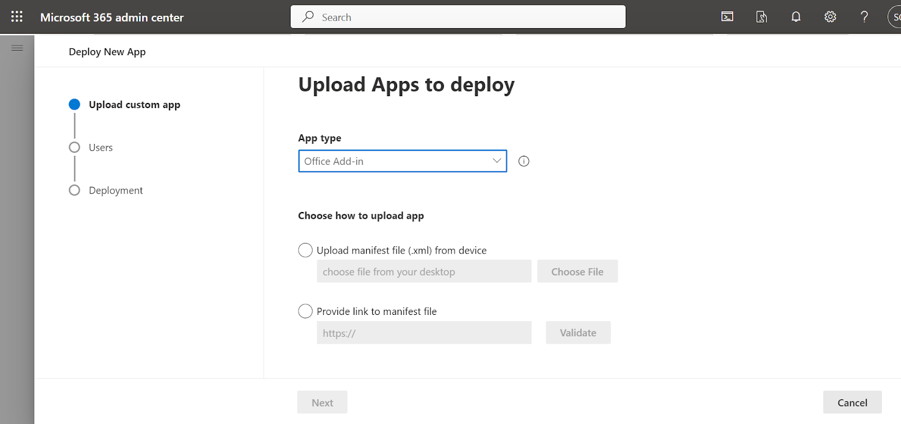
  - Add Type as Outlook Add-in, and choose Provide Link to manifest
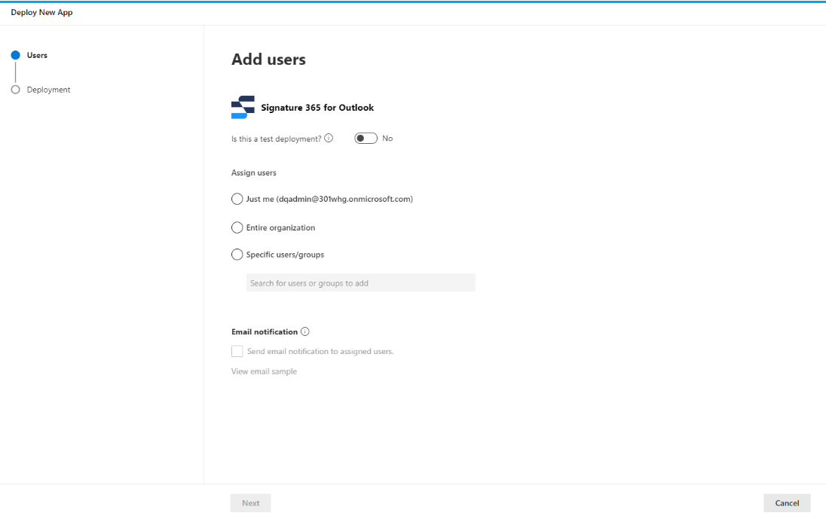
  - Set the settings for which users it will be deployed for
  - If you select the Specific users/groups option, Microsoft 365 will only deploy the add-in to users that are direct members of any groups you specify. Members of any nested groups will not be included. This is a limitation of Microsoft 365.
  - Click Next to continue to review permissions.
  - Click Next to continue to review and finish deployment.
  - Click Finish deployment to deploy the add-in.
  - It may take a minute for the deployment to complete and the confirmation to show.
  - The add-in may not be available to all users immediately. The deployment usually only takes a few minutes but can take up to 6 hours according to Microsoft. For some users the add-in may not be available until Outlook has been restarted.

